DEPARTMENT OF SOFTWARE ENGINEERING MOBILE APPLICATION DEVELOPMENT (SE-487)

**LAB SESSION 11**

**Margin & Padding, List Tile & Circle Avatars**

**Objective:**

To create a Flutter application that demonstrates the usage of ListView, BoxDecoration, and Expanded widget to display a list of items with customized styling.

**Introduction:**

In Flutter, both margin and padding are used to create space around and inside widgets, respectively. They play crucial roles in the layout and design of Flutter applications. Here’s a detailed explanation of each:

**Margin:**

Margin refers to the space outside the border of a widget. It helps in controlling the space between different widgets. To add margin in Flutter, you typically use the Container widget with the margin property.

The EdgeInsets class is used to define the margin. It has several constructors: EdgeInsets.all(double value): Same margin on all sides.

EdgeInsets.symmetric({double vertical, double horizontal}): Different margins for vertical and horizontal sides.

EdgeInsets.only({double left, double top, double right, double bottom}): Different margins for each side.

body:Padding( 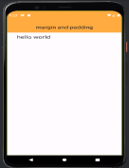

padding: const EdgeInsets.only(top:8,left:34),

child: Text('hello world',

style: TextStyle(fontSize: 23),),

),

);

}

}

DEPARTMENT OF SOFTWARE ENGINEERING MOBILE APPLICATION DEVELOPMENT (SE-487)

body:Padding( 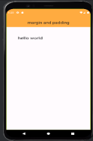

padding: const EdgeInsets.all(55),

child: Text('hello world',

style: TextStyle(fontSize: 23),),

),

);

}

}

**Padding**

Padding refers to the space inside the border of a widget. It creates space between the widget's content and its border.To add padding in Flutter, you can use either the Padding widget or the Container widget with the padding property. 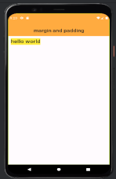

body:Container(

color:Colors.*yellow*,

margin: EdgeInsets.all(11),

child: Text('hello world',

style: TextStyle(fontSize: 23),),

),

);

}

}

DEPARTMENT OF SOFTWARE ENGINEERING MOBILE APPLICATION DEVELOPMENT (SE-487)

body:Container( 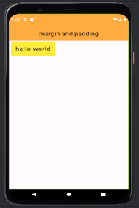

color:Colors.*yellow*,

margin: EdgeInsets.all(7),

child: Padding(

padding: const EdgeInsets.all(15.0),

child: Text('hello world',

style: TextStyle(fontSize: 23),),

),

),

);

}

}

**List Tile:**

In Flutter, a ListTile is a highly versatile and commonly used widget for creating a list of items with a consistent look and feel. It comes with several built-in properties that allow for easy customization, making it perfect for creating simple, single-line items as well as more complex, multi-line items. A basic ListTile includes a title and optionally a subtitle, leading and trailing widgets, and an onTap handler.

**Properties:**

leading: A widget to display before the title (typically an icon or an avatar). title: The main content of the list tile (typically a Text widget).

subtitle: Additional content displayed below the title (typically a Text widget). trailing: A widget to display after the title (typically an icon or a button).

isThreeLine: If true, the list tile will have space for three lines of text.

dense: If true, reduces the vertical size of the list tile.

contentPadding: Sets the padding around the tile’s content.

onTap: A callback that’s called when the tile is tapped.

onLongPress: A callback that’s called when the tile is long-pressed.

enabled: If false, the list tile is disabled and onTap/onLongPress callbacks won't be triggered. selected: If true, the list tile is in the selected state.

**body:**

**ListView.separated(itemBuilder: (context, index) {**

**index=index+1;**

**return ListTile(leading:Text('$index',**

**style: TextStyle(fontSize:20,fontWeight:FontWeight.*bold*),),**

DEPARTMENT OF SOFTWARE ENGINEERING MOBILE APPLICATION DEVELOPMENT (SE-487)

**title:Text(arrnames[index],** 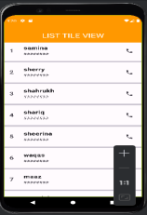

**style:TextStyle(fontSize: 20,fontWeight: FontWeight.*bold*)) ,**

**subtitle:Text('########'),**

**trailing:Icon(Icons.*phone*));**

**}**

**itemCount: arrnames.length,**

**separatorBuilder: (context,index){**

**return Divider(height:20,thickness: 6);**

**},**

**)**

**Circle Avatar:**

In Flutter, CircleAvatar is a widget that displays an image or text within a circular shape. It's commonly used for user profile pictures. The CircleAvatar widget provides a simple way to create circular images or icons, and it includes several customization options.

**Properties:**

backgroundColor: Sets the background color of the avatar.

backgroundImage: Provides an image to display as the background of the avatar. child: A widget to display inside the avatar, typically text or an icon.

foregroundColor: Sets the color for the avatar’s foreground elements, such as text or icons. radius: Defines the radius of the avatar. By default, it is 20.0.

minRadius: Sets the minimum radius for the avatar. Useful for responsive layouts. maxRadius: Sets the maximum radius for the avatar. Useful for responsive layouts. onBackgroundImageError: A callback function that gets triggered if there's an error loading the background image.

key: An identifier for the widget.

**body:Center(** 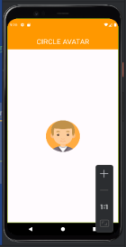

**child: CircleAvatar(**

**backgroundImage: AssetImage('assets/images/boy1.png'),**

**maxRadius: 60,**

**backgroundColor: Colors.orangeAccent,**

**),**

**)**

**);**

DEPARTMENT OF SOFTWARE ENGINEERING MOBILE APPLICATION DEVELOPMENT (SE-487)

**body:Center(** 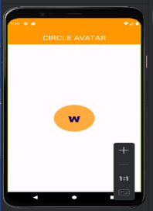

**child: CircleAvatar(**

**child: Text('w',**

**style: TextStyle(fontWeight: FontWeight.w900,fontSize: 50),),**

**maxRadius: 60,**

**backgroundColor: Colors.orangeAccent,**

**),**

**)**

**body:Center(**

**child: CircleAvatar(** 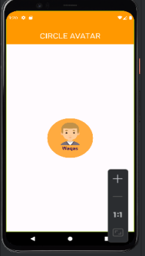

**backgroundColor: Colors.orangeAccent,**

**maxRadius: 70,**

**child:**

**Container(**

**child: Column(**

**children: [**

**Container(margin:EdgeInsets.only(top:15),**

**width:80,**

**height:80,**

**child: Image.asset( 'assets/images/boy1.png')),**

**Text('Waqas')**

**],**

**),**

**)**

**),**

**)**

DEPARTMENT OF SOFTWARE ENGINEERING MOBILE APPLICATION DEVELOPMENT (SE-487)

**Custom Font in Flutter:**

Adding a custom font to a Flutter project involves a few steps. Here’s a step-by-step guide to help you integrate custom fonts into your Flutter application:

**Step 1: Download the Font Files**

∙ Download the desired font files in .ttf or .otf format.

∙ Create a fonts directory in the root of your Flutter project (usually in the lib directory or at the root level).

**Step 2: Add Font Files to the Project**

∙ Place your font files into the fonts directory. For example, if you have a font named CustomFont.ttf, place it in the fonts directory.

**Step 3: Update the pubspec.yaml File**

∙ Open the pubspec.yaml file in the root of your Flutter project.

∙ Add the font details under the flutter section. Make sure to properly format the YAML. **Step 4: Use the Custom Font in Your App**

∙ Open the Dart file where you want to use the custom font.

∙ Use the TextStyle widget to specify the fontFamily.

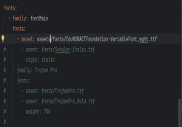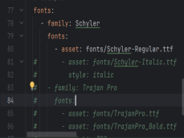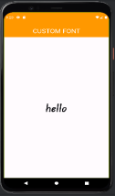

**body: Center(**

**child:**

**Text( 'Hello, Custom Font!',**

**style: TextStyle( fontFamily: 'CustomFont', fontSize: 24, ),**

**),**

**),**

DEPARTMENT OF SOFTWARE ENGINEERING MOBILE APPLICATION DEVELOPMENT (SE-487)

**Exercise**

**Question 1: ListTile with CircleAvatar, Trailing Icon, and Padding**

Create a ListTile with a CircleAvatar showing the initials "MD", a title of "Maaz Nadeem", a trailing icon of an arrow, and padding around the ListTile.

**Code**

//SE-21031 Musadique Hussain

//SE-21045 Muhammad Asim

import 'package:flutter/material.dart';

void main() {

  runApp(MyApp());

}

class MyApp extends StatelessWidget {

  @override

  Widget build(BuildContext context) {

    return MaterialApp(

      debugShowCheckedModeBanner: false,

      title: 'Flutter Demo',

      theme: ThemeData(

        primarySwatch: Colors.blue,

      ),

      home: MyHomePage(),

    );

  }

}

class MyHomePage extends StatelessWidget {

  @override

  Widget build(BuildContext context) {

    return Scaffold(

      appBar: AppBar(

        title: Text('ListTile with Circle Avatar'),

      ),

      body: Padding(

        padding: const EdgeInsets.all(8.0),

        child: ListTile(

          contentPadding: EdgeInsets.all(8.0),

          leading: CircleAvatar(

            child: Text('MD'),

          ),

          title: Text('Maaz Nadeem'),

          trailing: Icon(Icons.arrow_forward),

          onTap: () {

            // Handle tap

          },

        ),

      ),

    );

  }

}

**Output**

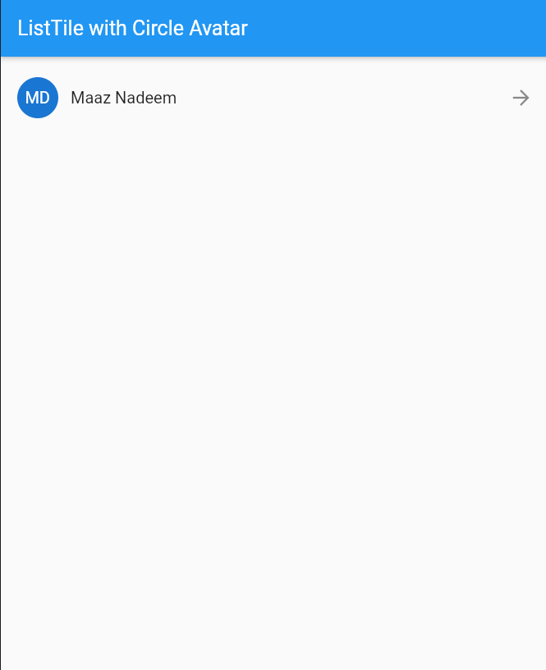

**Question 2: ListView of ListTiles with Different CircleAvatars and Padding**

Create a ListView containing three ListTile widgets, each with a CircleAvatar showing different initials, titles, and subtitles, and add padding around the entire list.

**Code**

//SE-21031 Musadique Hussain

//SE-21045 Muhammad Asim

import 'package:flutter/material.dart';

void main() {

  runApp(MyApp());

}

class MyApp extends StatelessWidget {

  @override

  Widget build(BuildContext context) {

    return MaterialApp(

      debugShowCheckedModeBanner: false,

      title: 'Flutter Demo',

      theme: ThemeData(

        primarySwatch: Colors.blue,

      ),

      home: MyHomePage(),

    );

  }

}

class MyHomePage extends StatelessWidget {

  @override

  Widget build(BuildContext context) {

    return Scaffold(

      appBar: AppBar(

        title: Text('ListTile with Circle Avatar'),

      ),

      body: Padding(

        padding: const EdgeInsets.all(8.0),

        child: ListView(

          children: [

            ListTile(

              contentPadding: EdgeInsets.all(8.0),

              leading: CircleAvatar(

                child: Text('MD'),

              ),

              title: Text('Maaz Nadeem'),

              trailing: Icon(Icons.arrow_forward),

              onTap: () {

                // Handle tap

              },

            ),

            ListTile(

              contentPadding: EdgeInsets.all(8.0),

              leading: CircleAvatar(

                child: Text('BW'),

              ),

              title: Text('Bruce Wayne'),

              trailing: Icon(Icons.arrow_forward),

              onTap: () {

                // Handle tap

              },

            ),

            ListTile(

              contentPadding: EdgeInsets.all(8.0),

              leading: CircleAvatar(

                child: Text("PP"),

              ),

              title: Text("Peter Parker"),

              trailing: Icon(Icons.arrow_forward),

              onTap: () {

                // Handle tap

              },

            )

          ],

        ),

      ),

    );

  }

}

Output

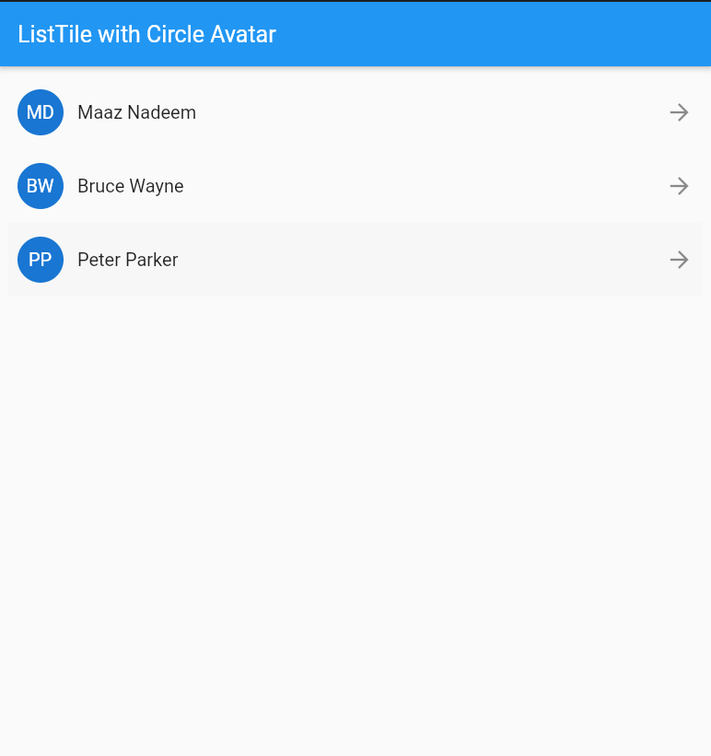

**Question 3: ListTile with CircleAvatar, Padding, and an onTap Event**

Create a ListTile with a CircleAvatar showing an image from assets, add padding around the ListTile, and implement an onTap event that prints "Tile tapped" to the console.

Code

//SE-21031 Musadique Hussain

//SE-21045 Muhammad Asim

import 'package:flutter/material.dart';

void main() {

  runApp(MyApp());

}

class MyApp extends StatelessWidget {

  @override

  Widget build(BuildContext context) {

    return MaterialApp(

      debugShowCheckedModeBanner: false,

      home: Scaffold(

        appBar: AppBar(title: Text('ListTile Example')),

        body: Padding(

          padding: const EdgeInsets.all(8.0),

          child: ListTile(

            leading: CircleAvatar(

              backgroundImage: AssetImage("lib/assets/images/Male.png"), // Ensure correct asset path

            ),

            title: Text("Musadique"),

            subtitle: Text("Click me"),

            onTap: () {

              print("I am Batman");

            },

          ),

        ),

      ),

    );

  }

}

**Output**

